Article ID: 3201
Article Name The lighting of my Fridge is flashing.
Topic Location: Cooling/Fridge/Error codes-Alarms/Display
Meta-data: fault, message, refrigerator
Related Articles:
Related Questions:
PNC
DIY
Safety
Link
Email
x Book Engineer
Multimedia
Brand
Article Content:
It is possibly because the appliance is placed in a garage, shed, outbuilding or other cold ot too warm environment.
Check the temperature classification as indicated on the rating plate and install appliance as advised.
The proper operation can only be guaranteed for a SN-class appliance in an ambient temperature of +10°C to +32°C.
- Class N = 16-32°C
- Class SN = 10-32°C
- Class ST = 18-38°C
- Class SN/T = 10-38°C
Climate classification indication on rating plate:
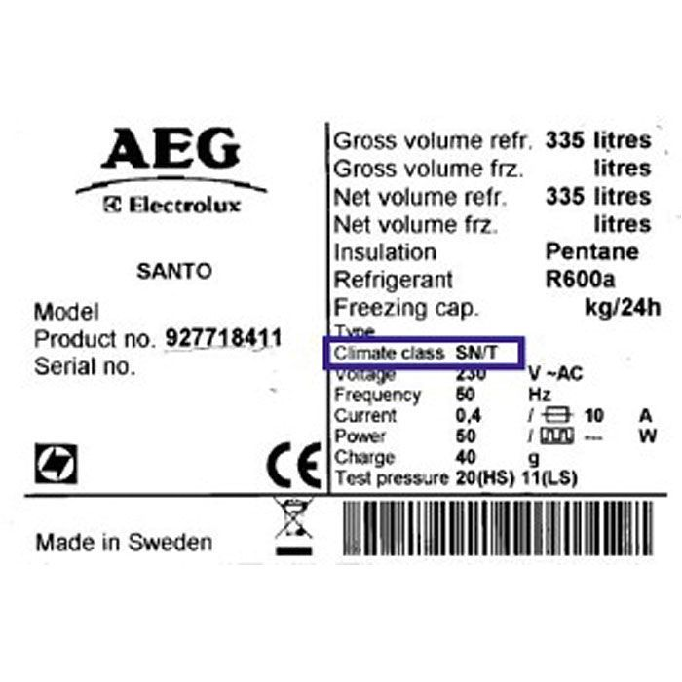
(book engineer design)

